CSCI 3403 Web Programming

Project #2 Webpage

Due Date: Midnight, Dec. 5, 2021

This project should be written in HTML/CSS/JS and/or PHP programming language and can be implemented through your IP address as WWW.

**Requirements:**

1. Use your SIS you build in PHP section to develop your webpage.
2. Have to have two different tabs: one for public, the other for staff (which is SIS).
3. Have to activate ‘update’ which is to modify the record(s) in SIS.
4. Load your webpage in Apache server installed in your machine.

**Rubric:**

1. Satisfying Requirements above: pass project #2
2. Bonus points are given when more professional design elements are added such as :

[www.okcu.edu](http://www.okcu.edu); [www.codepen.io](http://www.codepen.io); [www.apachefriends.org](http://www.apachefriends.org);

**Sample Output on a web:**

1. Main Page: there are two tabs: one for visitor (public), the other for staff

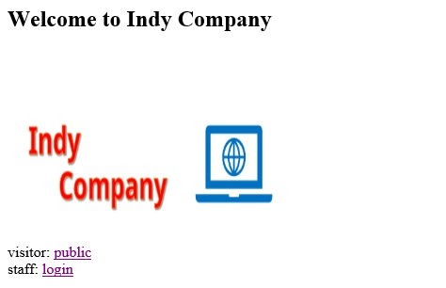

1. Click ‘public’ tab, then move to public page

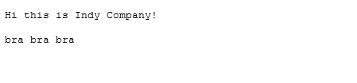

1. Back to Main page and click ‘login’ tab, then login system in SIS (or any other name) will be pop up as we did in class with ‘update’ functioning.

